Exercise 1
fs = 44100;
N = 8;
f = [0 3000 4000 8000 12000 fs/2];
a = [0 0 1 1 0 0];
W = [1 1 1];

f_norm = f / (fs/2);

b = firls(N, f_norm, a, W);

fvtool(b, 1);
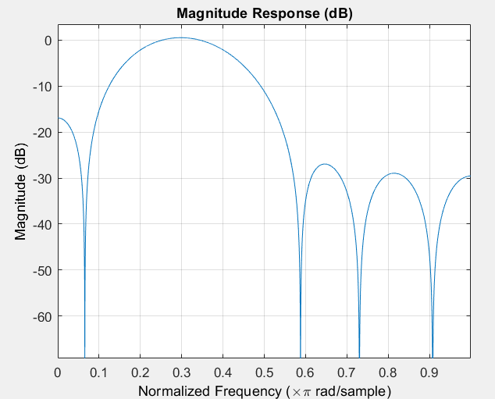
title('FIR Bandpass Filter - Least Squares Design');
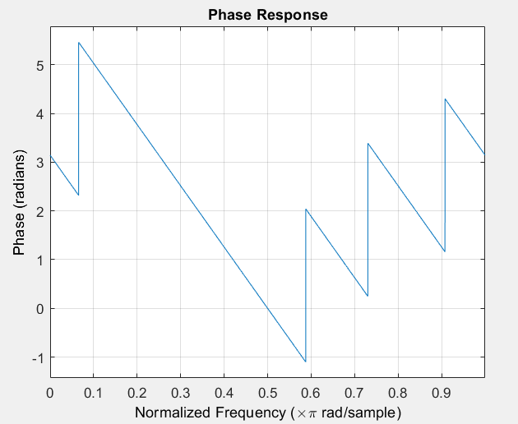

Exercise 2(a)
Rectangular Window
Fs = 32000;
Fc = 4000;
wc = 2*pi*Fc/Fs;
n = -20:20;

h = wc/pi * sinc(wc * n / pi);

x = cos(wc * n);

y = conv(x, h, 'same');

[H, w] = freqz(h, 1, 1024);
X = fftshift(fft(x, 1024));
Y = fftshift(fft(y, 1024));

w1=linspace(-pi, pi, 1024);

subplot(3,3,1); stem(n, h); title('Impulse Response h(n)');
subplot(3,3,2); plot(w/pi, abs(H)); title('|H(ω)|');
subplot(3,3,3); plot(w/pi, angle(H)); title('∠H(ω)');

subplot(3,3,4); stem(n, x); title('Input x(n)');
subplot(3,3,5); plot(w1, abs(X)); title('|X(ω)|');
subplot(3,3,6); plot(w1, angle(X)); title('∠X(ω)');

subplot(3,3,7); stem(n, y); title('Output y(n)');
subplot(3,3,8); plot(w1, abs(Y)); title('|Y(ω)|');
subplot(3,3,9); plot(w1, angle(Y)); title('∠Y(ω)');
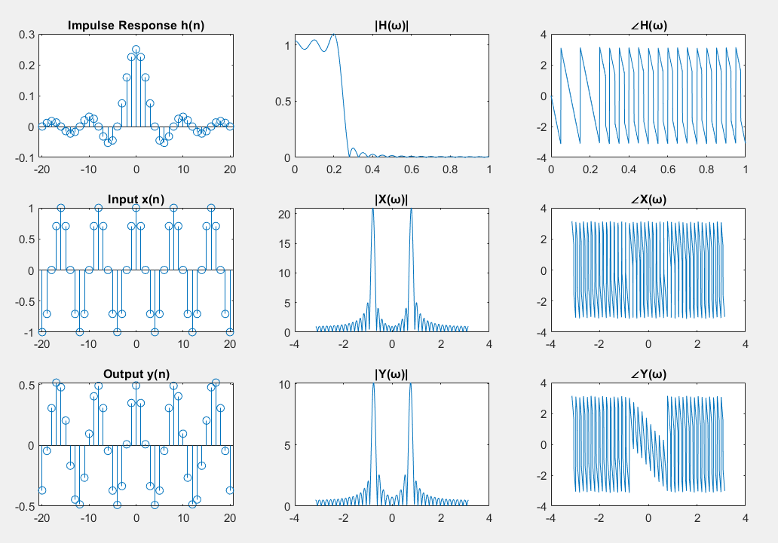

Hanning Window
Fs = 32000;
Fc = 4000;
wc = 2*pi*Fc/Fs;
n = -20:20;
L = length(n);

h_ideal = wc/pi * sinc(wc * n / pi);

w_hann = hann(L)';
h = h_ideal .* w_hann;

x = cos(wc * n);

y = conv(x, h, 'same');

[H, w] = freqz(h, 1, 1024);
X = fftshift(fft(x, 1024));
Y = fftshift(fft(y, 1024));
w1 = linspace(-pi, pi, 1024);

subplot(3,3,1); stem(n, h); title('Impulse Response h(n) with Hanning');
subplot(3,3,2); plot(w/pi, abs(H)); title('|H(ω)| with Hanning');
subplot(3,3,3); plot(w/pi, angle(H)); title('∠H(ω)');

subplot(3,3,4); stem(n, x); title('Input x(n)');
subplot(3,3,5); plot(w1, abs(X)); title('|X(ω)|');
subplot(3,3,6); plot(w1, angle(X)); title('∠X(ω)');

subplot(3,3,7); stem(n, y); title('Output y(n)');
subplot(3,3,8); plot(w1, abs(Y)); title('|Y(ω)|');
subplot(3,3,9); plot(w1, angle(Y)); title('∠Y(ω)');
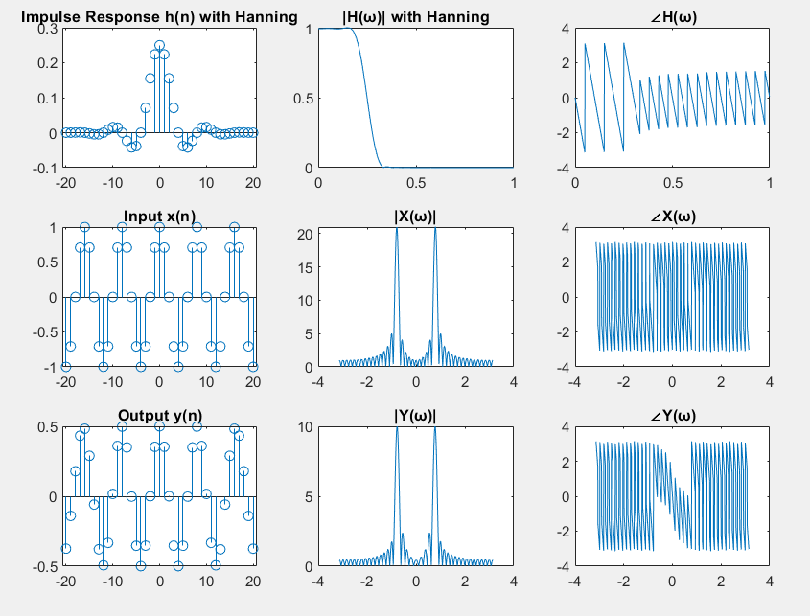

Hamming Window
Fs = 32000;
Fc = 4000;
wc = 2*pi*Fc/Fs;
n = -20:20;
L = length(n);

h_ideal = wc/pi * sinc(wc * n / pi);

w_hamming = hamming(L)';
h = h_ideal .* w_hamming;

x = cos(wc * n);

y = conv(x, h, 'same');

[H, w] = freqz(h, 1, 1024);
X = fftshift(fft(x, 1024));
Y = fftshift(fft(y, 1024));
w1 = linspace(-pi, pi, 1024);

subplot(3,3,1); stem(n, h); title('Impulse Response h(n) with Hamming');
subplot(3,3,2); plot(w/pi, abs(H)); title('|H(ω)| with Hamming');
subplot(3,3,3); plot(w/pi, angle(H)); title('∠H(ω)');

subplot(3,3,4); stem(n, x); title('Input x(n)');
subplot(3,3,5); plot(w1, abs(X)); title('|X(ω)|');
subplot(3,3,6); plot(w1, angle(X)); title('∠X(ω)');

subplot(3,3,7); stem(n, y); title('Output y(n)');
subplot(3,3,8); plot(w1, abs(Y)); title('|Y(ω)|');
subplot(3,3,9); plot(w1, angle(Y)); title('∠Y(ω)');
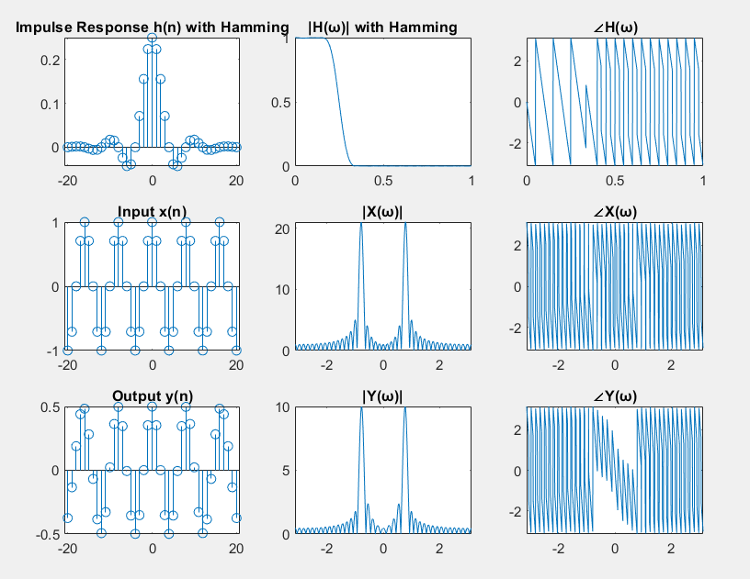

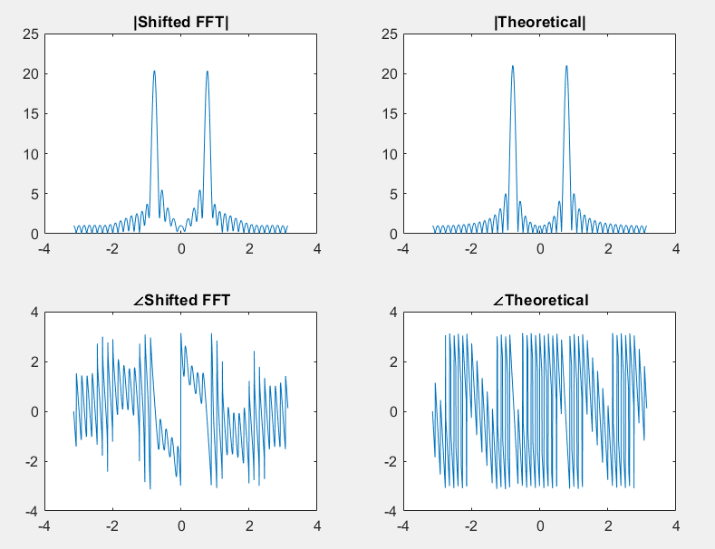
Exercise 2(b)
d = 5;
x_shifted = circshift(x, [0, d]);

X_shifted = fftshift(fft(x_shifted, 1024));

w = linspace(-pi, pi, 1024);
X_theory = exp(-1j * w * d) .* fftshift(fft(x, 1024));

subplot(2,2,1);plot(w, abs(X_shifted));
title('|Shifted FFT|');
subplot(2,2,2);plot(w, abs(X_theory));
title('|Theoretical|');
subplot(2,2,3);plot(w, angle(X_shifted));
title('∠Shifted FFT');
subplot(2,2,4);plot(w, angle(X_theory));
title('∠Theoretical');

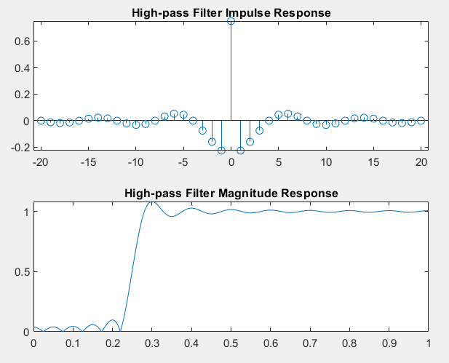
Exercise 2(c)
h = wc/pi * sinc(wc * n / pi);

h_lp = h;
h_hp = -h_lp;
center_index = find(n==0);
h_hp(center_index) = 1 + h_hp(center_index);

[H_hp, w_hp] = freqz(h_hp, 1, 1024);

subplot(2,1,1); stem(n, h_hp);
title('High-pass Filter Impulse Response');
subplot(2,1,2); plot(w_hp/pi, abs(H_hp));
title('High-pass Filter Magnitude Response');

